Japanese Br@ille 4 All

Alexis Culpin
L2 Frontières du Vivant

Summary of the project:
Braille is a tactile writing system for the visually impaired or blind. This system was developed by the Frenchman Louis Braille in 1929. The system is based on a set of combinations of six dots distributed over a cell composed of two columns of three dots. It has been used in many fields such as literature, mathematics and music.
However, Braille may differ from one country to another. Indeed, there is a different braille alphabet for each alphabet (Latin, Cyrillic, Greek, Japanese, etc...). Thus, when we learn braille in Western countries, we learn the classical 6 or 8 point version (called computer braille) which corresponds to the Latin alphabet. In addition, there can be minimal differences also within the same alphabet. For example, between French Braille and American (US) Braille, accents and punctuation will be translated by different symbols. Braille is therefore not a universal language.
When one wants to learn a foreign language with a different alphabet, there are two major problems:
- at present, the few documents that can be found on the subject are little or not adapted to those who have a real need for them. Indeed, the documents must be compatible with a screen reader, and/or a Braille computer to be read and used by the visually impaired.
- Adapted" tools are only "adapted" for a Braille type. For example, a braille computer designed for the French market will only take into account French braille. There are also some translation software such as Duxbury Braille Translator, but they are very expensive. Access to this knowledge is therefore severely limited by financial resources.
It is from these issues and my desire to learn Japanese that this project was born. For the past three months, I have been working on this project which consists of i) creating documentation on Japanese braille specially designed to be easily read by a screen reader and a braille computer and ii) writing an open source computer program capable of transcribing Japanese (Kanas only) into Japanese braille (Tenji) and vice versa.
Regarding the target audience, this project will benefit anyone who wants to learn Japanese and/or Japanese braille. Once the documentation is finished, I will make it available to everyone by providing it to various associations such as Valentin Haüy, Mes Mains en Or, etc... as well as free access on the web. In addition, I have contacted Eurobraille, which is a company that designs adapted equipment, in order to incorporate this new Braille alphabet into their devices.

The realization of this project was done in several stages:
1. Design of the documentation
This consists of gathering the symbols of Japanese Braille, understanding the specific writing rules of Japanese Braille, creating correspondence tables between the different alphabets and formatting adapted documents.
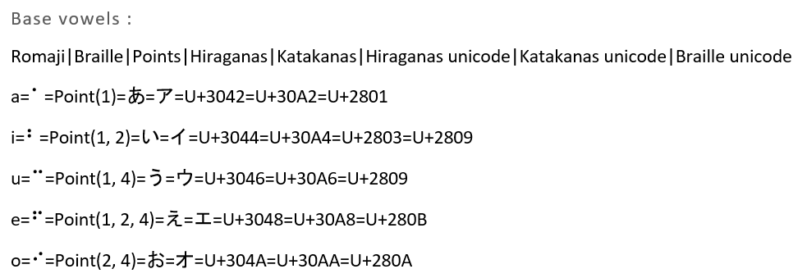

Figure 1 - Documentation compatible with a screen reader (NVDA). From left to right: Roman alphabet letter (Romaji), Japanese braille letter, description of braille symbol, Hiraganas letter (Japanese common alphabet), Katakanas letter (Japanese alternative alphabet mainly used for words of foreign origin), unicode encoding of Hiraganas, Katakanas, and Japanese braille.
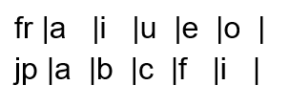
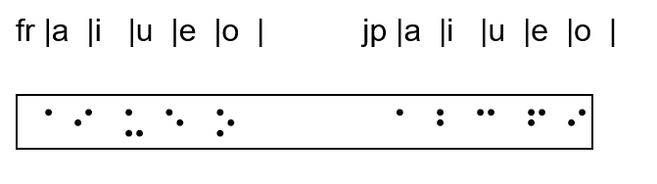

Figure 2 - Documentation compatible with a Braille computer. On the left, transcription of the same vowels in French braille and a Japanese braille. In the center, an example of poor transcription of Japanese Braille. The word chat (neko - ネコ) with its Japanese Braille transcription will be interpreted on a screen as the word 'P9' in the absence of Japanese Braille support. On the right, conversion table between French and Japanese braille. The symbol of the letter i in French braille is identical to the symbol of the letter b in Japanese braille.

2. Design of a transcription program
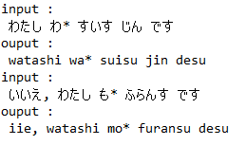
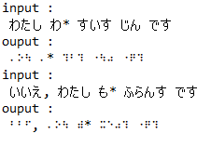
The purpose of the program is to allow the transcription of documents in Kanas (Japanese alphabet) into Tenji (Japanese braille), Romaji (Latin alphabet) or French braille and vice versa. The transcription can be made from one of the four possible types of document in input and give the desired type in output.

Figure 3 - Example of transcription by the program. On the left, transcription of Hiraganas in Romaji and on the right, Hiraganas in Tenji.
The program is still under development. It is necessary to optimize it, to decrease its sensitivity to the case, and to integrate a graphic interface.
3. Collaboration with Eurobraille to include a Japanese braille mode in their products.
Adaptive devices such as computers and Braille displays have different modes (computer Braille, literary, mathematical, musical) to read different types of media. The conversion of black media (anything not written in Braille) to Braille is done directly by the device's system.
The purpose here is to include a new mode that allows conversion of documents written in Japanese to Japanese Braille and vice versa. According to a telephone exchange with a Eurobraille employee, this would be possible thanks to the conversion tables previously established.

